# JS Advanced Retake - 08 August 2019

Exam problems for the [JavaScript Essentials” course @ SoftUni](https://softuni.bg/courses/js-essentials). Submit your solutions in the SoftUni Judge system at <https://judge.softuni.bg/Contests/Practice/Index/1772#0>.

## Problem 1. BookUni

### Use the provided skeleton to solve this problem.

### You can't, and you have no permission to change directly the given html code (index.html file).

### Your Task

**Write the** **missing JavaScript code** to make the **Book Store (BookUni)** work as expected:

* When **all fields (title, year and price)** are **filled with correct input**
  + **Title** is **non**-**empty** **strings**
  + **Year** and **Price** need to be **positive** **numbers**
* Upon pressing the **[Add new book]** **button**, a new book should appear in the bookshelf section. Create new **div** **element** with **class** **book** (for every created book) which hold:
  + **paragraph** with text content of the given book title and the given book year in format: **"{bookTitle} [{bookYear}]"**
  + **button** with text content "**Buy it only for {bookPrice} BGN**" and **functionality** when is being clicked the **current book should be removed** from the current section and the **total store profit** is **increased** with the given **book price**.
  + (**only applies to new books**) **button** with text content "**Move to old section**" which have the **functionality** when is being clicked the current book should be **moved** from the new books section to the **old books section**.

### Constraints

Every price should be **rounded** to the **second** **decimal** **part (**a.k.a **toFixed(2)**)

Every **old book price** has **15% discount** from the **initial value** (When being **created** into the **old** **books** **sections** or being **moved** from the new books section to **the old books section**)

Each **book's year** **equal** or **higher** than **2000** is consider for a **new book.**

### Submission

Submit only yours **solve()** function.

### Examples

#### Create a new book

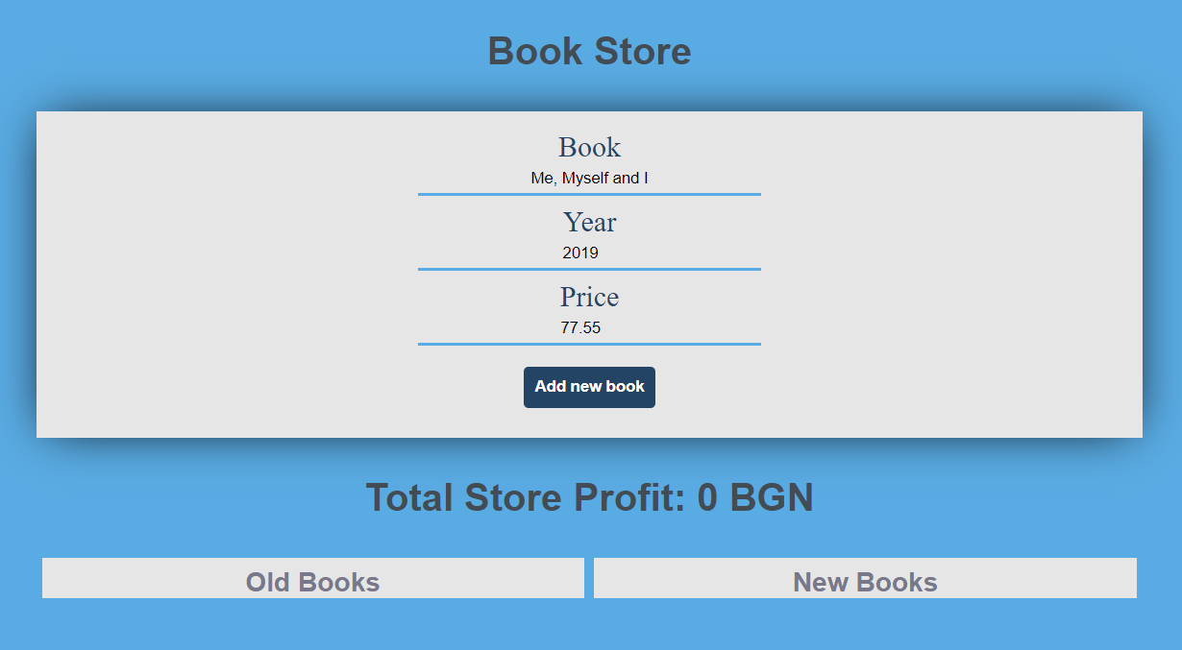

**After** we hit the **[Add]** **button**

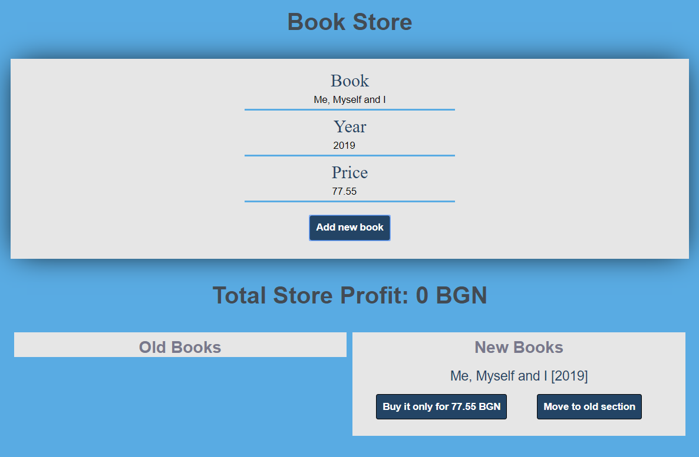

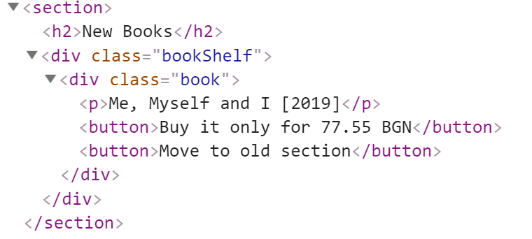

#### Create an old book

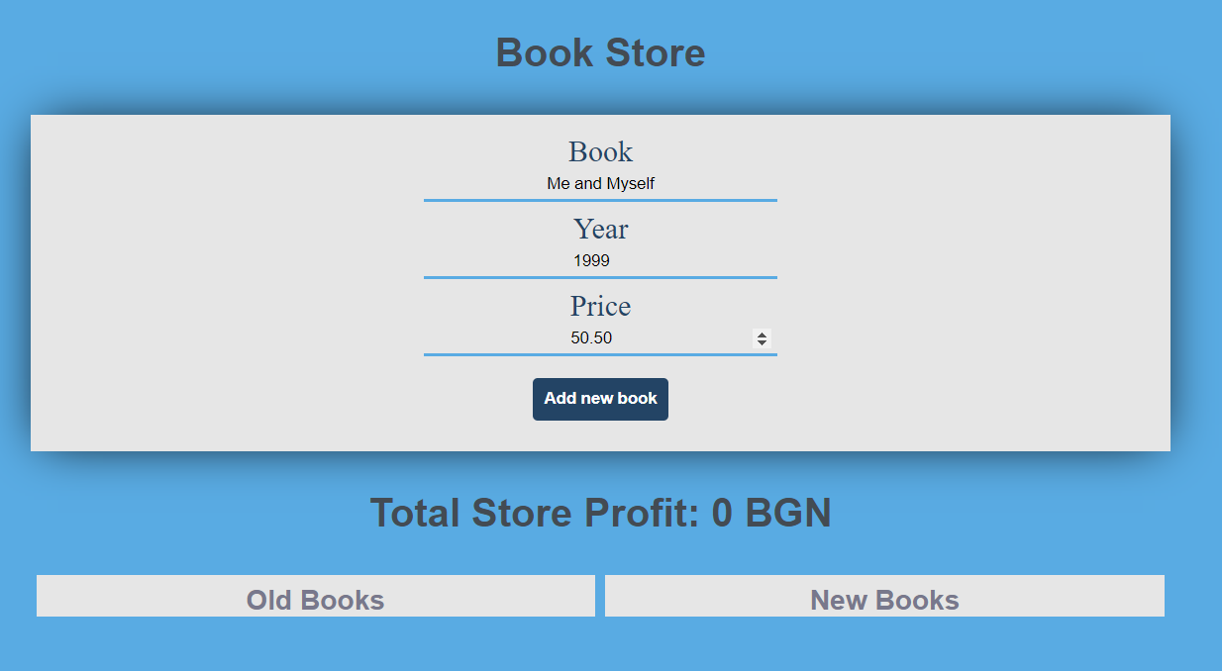

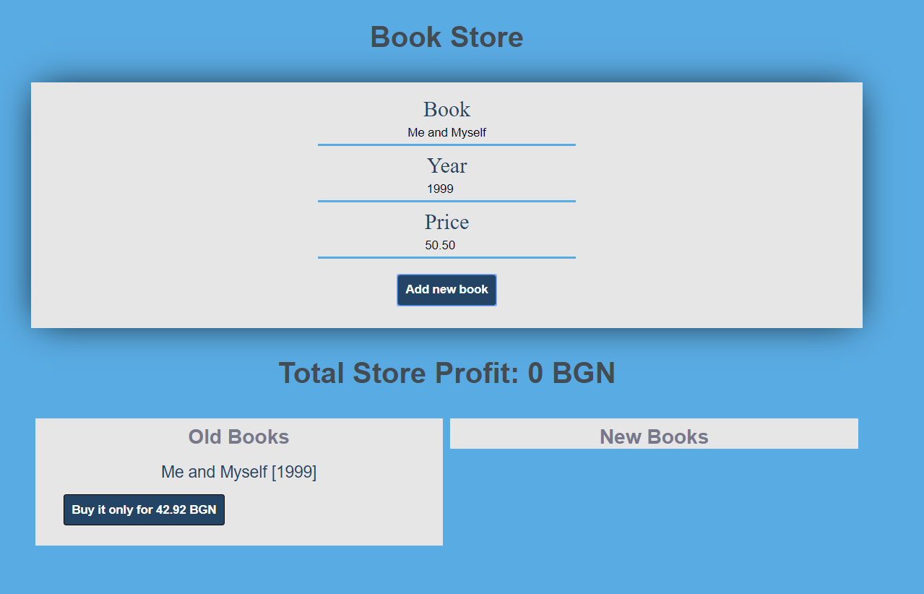

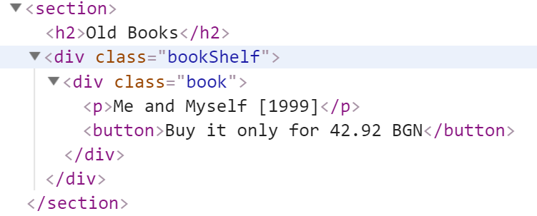

#### Buy a book

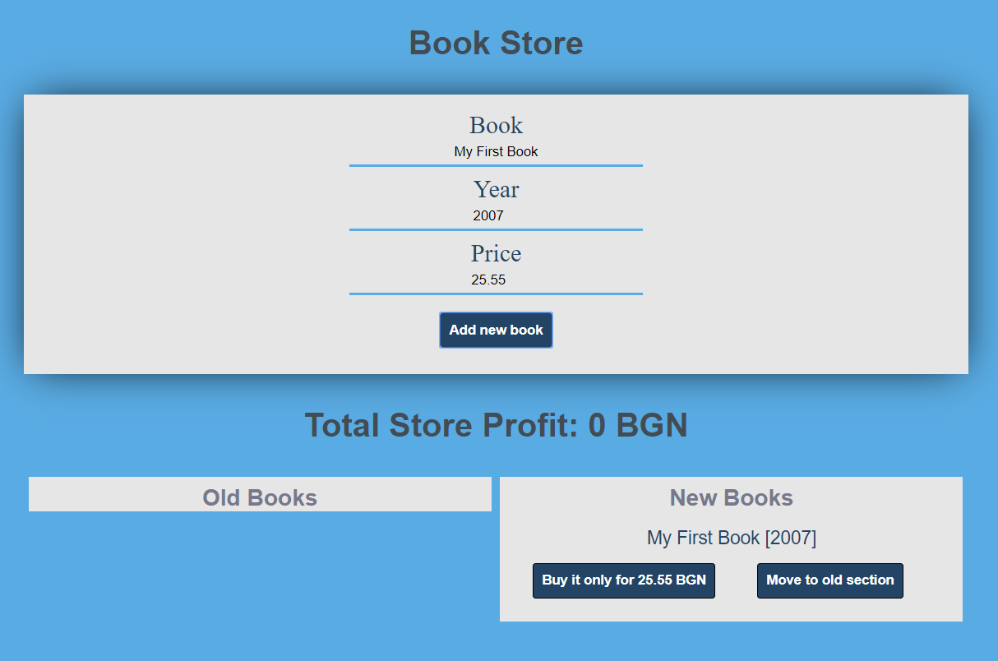

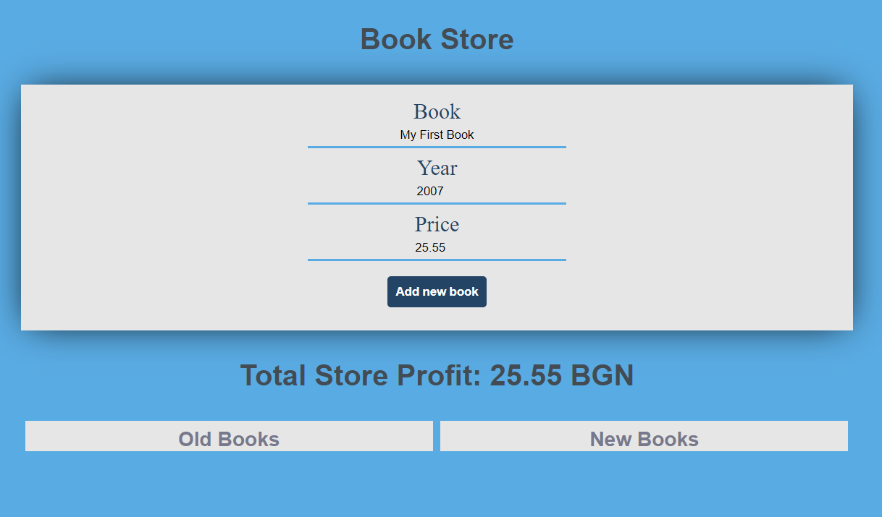

#### Move new book to the old section

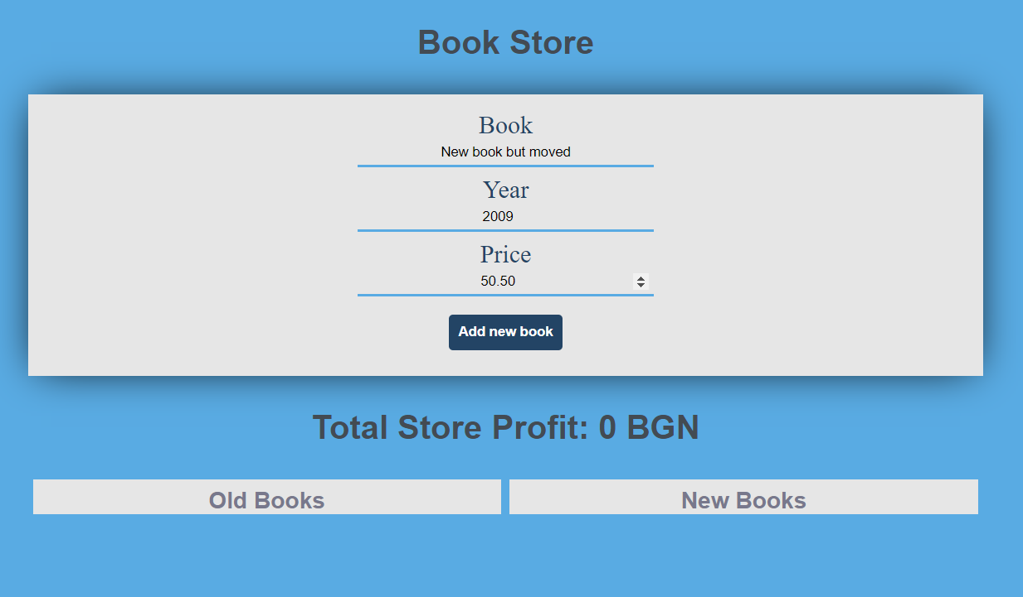

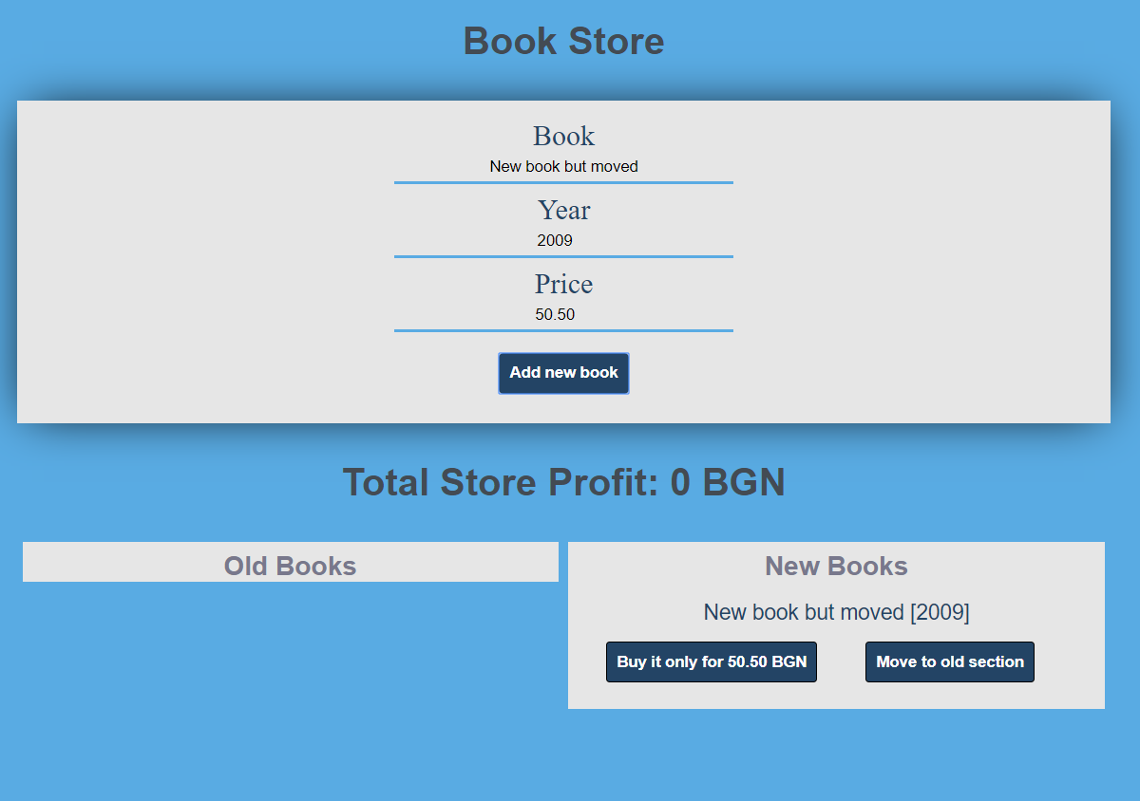

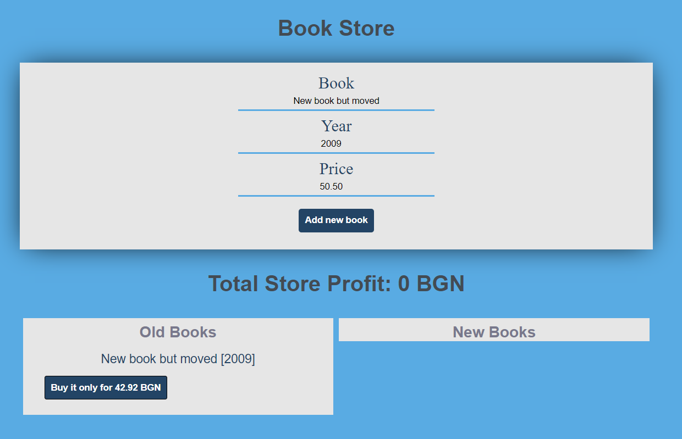

**Problem 2. Book Store**

Use the provided **BookStore class** to solve this problem.

**Your Task**

Using **Mocha** and **Chai** write **JS Unit Tests** to test the entire functionality of the **BookStore** **class**. Make sure instances of it have all the required functionality and validation. You may use the following code as a template:

|  |
| --- |
| describe(**"*Tests* …"**, **function**() {  describe(**"*TODO* …"**, **function**() {  ***it***(**"*TODO …*"**, **function**() {  *//* ***TODO:*** …  });  });  *//* ***TODO:*** …  }); |

**Functionality**

**bookStore.js** defines a **class** that contains information about a **book store**. An **instance** of the class should support the following operations:

* **Instantiation** with **one** **parameter** - a **string** representing the **bookstore name,** and an **additional properties** called "**books**" and "**workers**" - an **empty arrays by default**.
* Function **stockBooks()** - receives **one** parameter - **newBooks** (an **array** of **strings**). This function adds **each of the elements** from the input into the **book's** **property**.
* Function **hire()** - receives **two** parameters: a **string** (**name**) and another **string** (**position**). If the worker is **already hired** the function **throws** an **error**, otherwise the worker is **hired**, and a proper **message** is **returned**.
* Function **fire()** - receives **one** parameter - **workerName.** If there is an employee with that name, he is fired, and a proper message is returned . Otherwise, an **error** is **thrown**.
* Function **sellBook()** - receives two parameters: a **string** (**title**) and another **string** (**workerName**). If the book is in **stock** and the given worker name is **present** in the workers property, the book is **sold,** and the current worker **books** **sold** **counter** is **increased** by 1 . Otherwise, an **errors** is **thrown**.
* Function **printWorkers()** - This function **prints all workers.**

Check the given class for more clarity!

**Examples**

|  |
| --- |
| **Sample Code Usage** |
| let store = new BookStore('Store');  store.stockBooks(['Inferno-Dan Braun', 'Harry Potter-J.Rowling', 'Uncle Toms Cabin-Hariet Stow', 'The Jungle-Upton Sinclear']);  console.log(store.hire('George', 'seller'));  console.log(store.hire('Ina', 'seller'));  console.log(store.hire('Tom', 'juniorSeller'));  store.sellBook('Inferno', 'Ina');  store.stockBooks(['Harry Potter-J.Rowling']);  console.log(store.fire('Tom'));  console.log(store.printWorkers()); |
| **Corresponding Output** |
| George started work at Store as seller  Ina started work at Store as seller  Tom started work at Store as juniorSeller  Tom is fired  Name:George Position:seller BooksSold:0 Name:Ina Position:seller BooksSold:1 |

**Submission**

Submit your tests inside a **describe()** statement, as shown above.

# Problem 3. Library

**class** Library {  
 *//* ***TODO: implement this class...***  
}

### Your Task

### Write a Library class which supports the described functionality below.

### Functionality

#### constructor()

Receives **1** parameters at initialization of the class (**libraryName**), where library name is a **string.**

Should have at least these **3** properties:

* **libraryName** - **string** (should be the same as the received **libraryName**)
* **subscribers** - **empty** **array**
* **subscriptionTypes** - object with properties **normal, special** and **vip**
  + The number of books that a person with **normal** subscription can receive is equal to the **length of the libraryName**
  + The number of books that a person with **special** subscription can receive is equal to the **length of the libraryName multiplied by 2 (libraryName * 2)**
  + A person with **vip** subscription can receive unlimited(**Number.MAX_SAFE_INTEGER**) amount of books

#### subscribe(name, type)

This **function** receives **2 string** parameters - **name** and **type**

* If the given subscription **type** is not **normal**, **special** or **vip**, a new error should be **thrown** with the following message: **"The type {type} is invalid"**
* If the person **is not subscribed**, you should make **new** **subscriber** **object** with properties
  + **name** (the subscriber name)
  + **type** (the subscription type)
  + **books** (an empty array by default)

and add it to the library subscribers' array.

* If there is a person with that **name** in the **subscribers** list, you should just **change** his subscription **type** with the given type.

This function should **return** the current **subscriber**.

#### unsubscribe(name)

This **function** receives **1** parameter **name** and should **unsubscribe** an **already** **subscribed** person in the library (**remove** the person with the **given** **name** from the **subscriber's** **property**).

* If there **is no subscriber** with that **name,** a **new error** should be **thrown** with the following message: "**There is no such subscriber as {name}**"
* If **subscribers** **property** contains a person with the **given** **name**, that person should be **removed** from the array.

This function should **return** the library's **subscribers** list

#### receiveBook(subscriberName, bookTitle, bookAuthor)

This function receives **3** parameters **(subscriberName, bookTitle** and **bookAuthor**) and should **add** a book to the **subscriber's** book list.

* If there is **no** such subscriber in the **subscriber's** array, a new error should be **thrown** with the following message: **"There is no such subscriber as {name}"**
* If there is a subscriber with that name you should **check** his subscription **type**:
  + If his subscription type **allows** him to **receive** more book you should **add** a new **book** **object** with properties **title** and **author** to his books array
  + Otherwise a new error should be thrown, with the following message:

**"You have reached your subscription limit {subTypeLimit}!"**

This function should return the **subscriber** with the given name.

#### showInfo ()

This function should **return a string with all the subscribers** with their books joined by (**", "**) in the following format:

**"Subscriber: {subscriberName}, Type: {subscriptionType}\n**

**Received books: {title} by {author}, {title2} by {author2}…"**

If the subscriber's property in the Library is empty just **return** the following string:

**"{libraryName} has no information about any subscribers"**

### Submission

Submit only your **Library class.**

### Examples

This is an example how the code is **intended to be used**:

|  |
| --- |
| Sample code usage |
| let **lib** **=** **new** Library(**'Lib'**);  **lib.**subscribe(**'Peter'**, **'normal'**);  **lib.**subscribe(**'John'**, **'special'**);  **lib.**receiveBook(**'John'**, **'A Song of Ice and Fire'**, **'George R. R. Martin'**);  **lib.**receiveBook(**'Peter'**, **'Lord of the rings'**, **'J. R. R. Tolkien'**);  **lib.**receiveBook(**'John'**, **'Harry Potter'**, **'J. K. Rowling'**);  console**.**log(**lib.**showInfo()); |
| Corresponding output |
| Subscriber: Peter, Type: normal  Received books: Lord of the rings by J. R. R. Tolkien  Subscriber: John, Type: special  Received books: A Song of Ice and Fire by George R. R. Martin, Harry Potter by  J. K. Rowling |